Hello Students and Families

I hope you all are continuing to stay healthy and happy while learning at home. It’s been great to hear back from students, and I’m pleased to hear that many of you are also noticing the same birds in your backyards or neighbourhoods as we are! This week my husband saw a Pine Grosbeak and I think I saw an Anna’s Hummingbird. I was VERY disappointed to miss seeing the Pine Grosbeak!
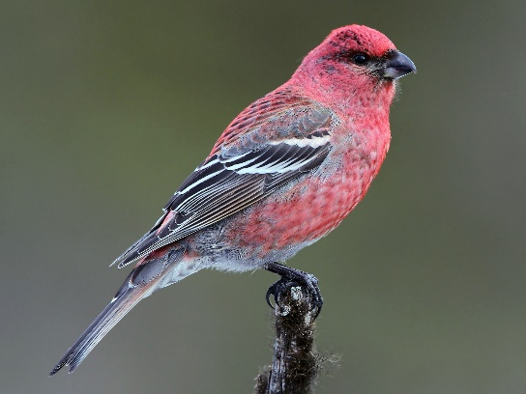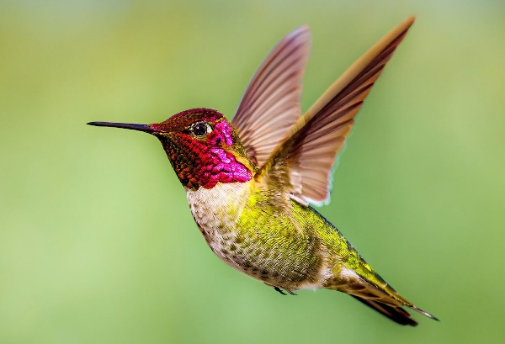
This week I have an electropop (a type of electronic dance music) song for you to listen to, as well as a link to an online beat maker that can be a lot of fun. I would love to hear some of your compositions if you decide to try it out! See the Music Appreciation document for instructions on how to do this.
*Parents, please pre-view all YouTube videos and other online media before showing them to your children. While I am very careful about song and video content, sometimes ads come up before or after these videos that may not be appropriate. The same thing goes for YouTube content that might come after the video I send.*
As always, I would love to hear what you thought of the song, and what kinds of birds you are seeing!
Bye for now,
Mme Carmen

Music Genre Appreciation

Type of music: Electropop
Artist: Oliver featuring Sam Sparro
Title of song: Last Forever https://www.youtube.com/watch?v=B6drRDJIJfE
This song is by a Canadian artist who is currently living in Los Angeles. He goes by the stage name Oliver and his real name is Vaughn Oliver. I have a very special connection to this artist: he is my cousin! Vaughn has been creating music ever since he was in high school, starting with record scratching and mixing. He is now a producer (someone who helps artists get the sound they want for their music), composer, and artist. This kind of music is called Electropop, which is a kind of Electronic Dance Music (EDM for short). Vaughn uses sophisticated equipment – mainly synthesizers (electronic instruments that can create and imitate countless sounds, including the sound of instruments, voices, etc) - to create music. He also creates “sample packs” of difference sounds for other EDM artists to use in their songs. You can check it out here: https://splice.com/sounds/splice/oliver-power-tools. Here is a short video of Vaughn talking about how he creates music: https://www.youtube.com/watch?v=JpwOLZGWcK0.
Speaking of synthesizers, if you have an iPad or iPhone, you can download the KORG Module or Moog app for free (these app usually cost money but are currently offered for free). These apps mimic famous synthesizers and can be a lot of fun to play with!

- What instruments/sounds do you hear? Do you think these instruments are “real” or sounds created by synthesizers?
- How does this music make you feel?
- Do they lyrics tell a story or are they repetitive?
Bonus Challenge
Go to https://splice.com/sounds/beatmaker and create your own beats. If you sign up for a free account (ask an adult in your house if this is okay first), you can save your songs and even share them with friends, family and your music teacher! I would love to hear what you create.

